Constructing Parallelogram

Definition
# Source: AI Source: Provided by: [Data Path: Persons Table -> ID Column: 1, Name_En Column: Motasem Essam] -> From: [ChatGPT] on [7/25/2026]
Constructing a Parallelogram is the geometric construction of a quadrilateral with two pairs of opposite sides parallel, using classical geometric tools such as a straightedge and compass.
A parallelogram $ABCD$satisfies:
$$\boxed{AB∥CD}$$
and:
$$\boxed{AD∥BC}$$
Its opposite sides are also equal:
$$\boxed{AB=CD} \\ \boxed{AD=BC}$$

Fundamental Concept
# Source: AI Source: Provided by: [Data Path: Persons Table -> ID Column: 1, Name_En Column: Motasem Essam] -> From: [ChatGPT] on [7/25/2026]
A parallelogram can be constructed when sufficient information is given, such as:
- two adjacent sides and the included angle
- three vertices
- two adjacent sides and a diagonal
- two adjacent side lengths and an angle
- a base, height, and additional directional information
The most fundamental construction is a parallelogram from two adjacent sides and their included angle.
Suppose:
$$AB=a \\ AD=b$$
and:
$$∠DAB=θ$$
Then the goal is to construct $ABCD$such that:
$$AB∥CD$$
and:
$$AD∥BC$$

Main Construction: Two Adjacent Sides and Included Angle
# Source: AI Source: Provided by: [Data Path: Persons Table -> ID Column: 1, Name_En Column: Motasem Essam] -> From: [ChatGPT] on [7/25/2026]
Suppose $AB$, $AD$, and $∠DAB$are specified.
Steps
- Construct the first side:
$$AB=a$$
- At $A$, construct the given angle:
$$∠DAB=θ$$
- On the second ray, mark point $D$such that:
$$AD=b$$
- Through $B$, construct a line parallel to $AD$.
- Through $D$, construct a line parallel to $AB$.
- Let the two parallel lines intersect at $C$.
- Connect the vertices:
$$A-B-C-D-A$$
- The resulting quadrilateral is a parallelogram.
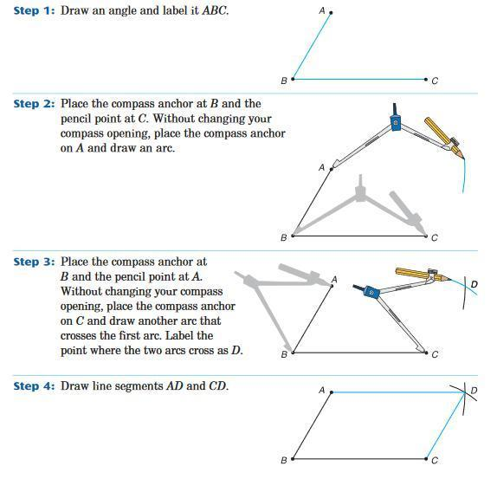
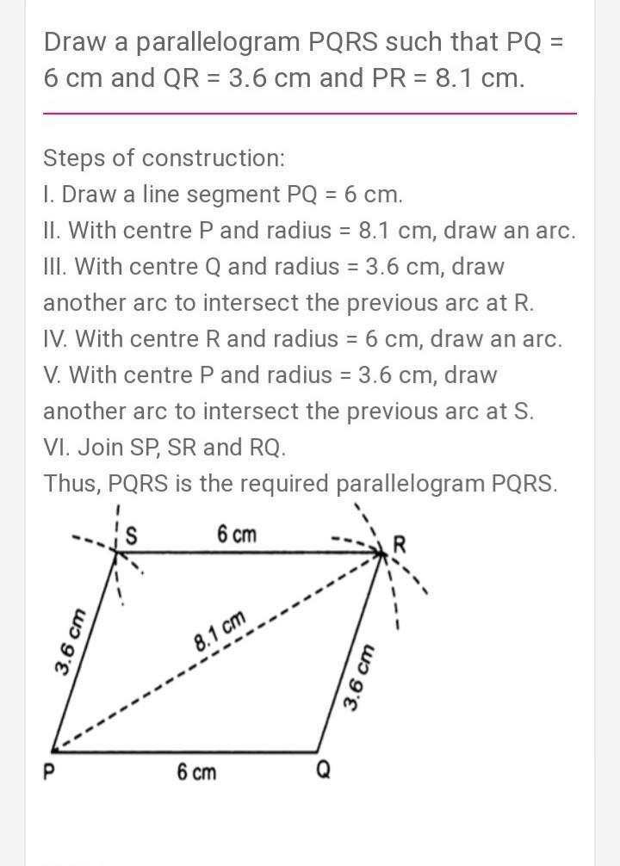
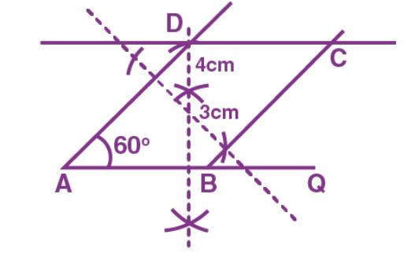
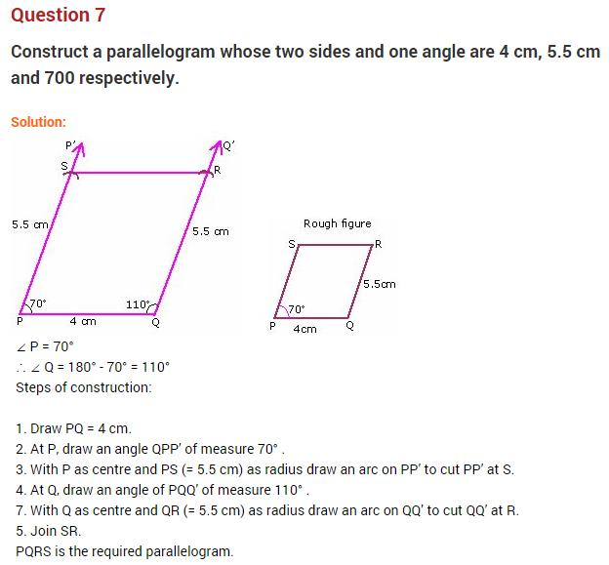
Result
$$\boxed{AB∥CD} \\ \boxed{AD∥BC}$$
and therefore:
$$\boxed{ABCD\text{ is a parallelogram}}$$

Why the Construction Works
# Source: AI Source: Provided by: [Data Path: Persons Table -> ID Column: 1, Name_En Column: Motasem Essam] -> From: [ChatGPT] on [7/25/2026]
The construction deliberately creates two pairs of parallel lines.
Through $B$, we construct:
$$BC∥AD$$
Through $D$, we construct:
$$CD∥AB$$
Therefore:
$$\boxed{AB∥CD}$$
and:
$$\boxed{AD∥BC}$$
A quadrilateral with both pairs of opposite sides parallel is, by definition, a parallelogram.

Constructing a Parallelogram from Three Given Vertices
# Source: AI Source: Provided by: [Data Path: Persons Table -> ID Column: 1, Name_En Column: Motasem Essam] -> From: [ChatGPT] on [7/25/2026]
Suppose three vertices $A$, $B$, and $D$are given.
The fourth vertex $C$can be constructed by using parallel lines.
Steps
- Draw $AB$.
- Draw $AD$.
- Through $B$, construct a line parallel to $AD$.
- Through $D$, construct a line parallel to $AB$.
- Let the two parallel lines intersect at $C$.
- Connect the vertices.
Then:
$$\boxed{ABCD\text{ is a parallelogram}}$$
because:
$$AB∥CD$$
and:
$$AD∥BC$$

Constructing a Parallelogram from Two Adjacent Sides
# Source: AI Source: Provided by: [Data Path: Persons Table -> ID Column: 1, Name_En Column: Motasem Essam] -> From: [ChatGPT] on [7/25/2026]
If the lengths of two adjacent sides are given:
$$AB=a$$
and:
$$AD=b$$
an included angle or an equivalent directional condition is also needed to determine the shape.
For example, if:
$$∠DAB={60}^{∘}$$
then:
- Construct $AB=a$.
- Construct a ${60}^{∘}$angle at $A$.
- Mark $AD=b$.
- Through $B$, construct a line parallel to $AD$.
- Through $D$, construct a line parallel to $AB$.
- Their intersection is $C$.
The parallelogram is now completely determined.
Important
Two side lengths alone do not uniquely determine a parallelogram.
For example:
$$AB=6\text{ cm}, AD=4\text{ cm}$$
could produce many different parallelograms depending on the included angle.

Constructing a Parallelogram from a Base and Height
# Source: AI Source: Provided by: [Data Path: Persons Table -> ID Column: 1, Name_En Column: Motasem Essam] -> From: [ChatGPT] on [7/25/2026]
Suppose the base $AB$and perpendicular height $h$are given.
Steps
- Construct:
$$AB=a$$
- Construct a line parallel to $AB$at perpendicular distance:
$$h$$
- Choose a point $D$on the second parallel line.
- Through $D$, construct a line parallel to $AB$.
- Through $B$, construct a line parallel to $AD$.
- Their intersection gives $C$.
The perpendicular distance between the parallel sides is:
$$\boxed{h}$$
The area is:
$$\boxed{A=bh}$$
where $b$is the base length.

Constructing a Parallelogram from a Diagonal
# Source: AI Source: Provided by: [Data Path: Persons Table -> ID Column: 1, Name_En Column: Motasem Essam] -> From: [ChatGPT] on [7/25/2026]
A parallelogram can also be constructed when one diagonal and sufficient additional information are given.
If diagonal $AC$is known and a second vertex $B$is specified:
- Construct $AC$.
- Through $B$, construct a line parallel to $AC$.
- Use the remaining given information to locate $D$.
- Construct the required parallel lines.
- Complete the parallelogram.
A particularly useful property is that the diagonals of a parallelogram bisect each other.
If $AC$and $BD$intersect at $O$:
$$\boxed{AO=OC}$$
and:
$$\boxed{BO=OD}$$
Therefore, if three of the four points associated with the diagonals are known, the fourth can sometimes be located using the midpoint property.

Properties of a Constructed Parallelogram
# Source: AI Source: Provided by: [Data Path: Persons Table -> ID Column: 1, Name_En Column: Motasem Essam] -> From: [ChatGPT] on [7/25/2026]
For parallelogram $ABCD$:
Opposite Sides Are Parallel
$$\boxed{AB∥CD} \\ \boxed{AD∥BC}$$
Opposite Sides Are Equal
$$\boxed{AB=CD} \\ \boxed{AD=BC}$$
Opposite Angles Are Equal
$$\boxed{∠A=∠C} \\ \boxed{∠B=∠D}$$
Consecutive Angles Are Supplementary
$$\boxed{∠A+∠B={180}^{∘}}$$
Diagonals Bisect Each Other
If the diagonals intersect at $O$:
$$\boxed{AO=OC} \\ \boxed{BO=OD}$$
Area
For base $b$and perpendicular height $h$:
$$\boxed{A=bh}$$
Perimeter
If adjacent sides are $a$and $b$:
$$\boxed{P=2\left(a+b\right)}$$

Types of Parallelogram Construction
# Source: AI Source: Provided by: [Data Path: Persons Table -> ID Column: 1, Name_En Column: Motasem Essam] -> From: [ChatGPT] on [7/25/2026]
These are primarily construction situations, rather than different mathematical types of parallelograms.
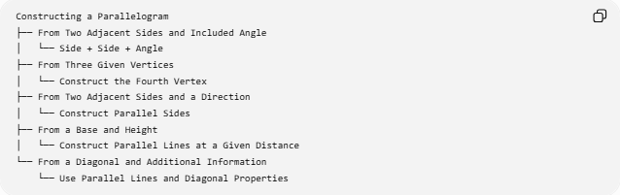
Constructing a Parallelogram
├── From Two Adjacent Sides and Included Angle
│ └── Side + Side + Angle
├── From Three Given Vertices
│ └── Construct the Fourth Vertex
├── From Two Adjacent Sides and a Direction
│ └── Construct Parallel Sides
├── From a Base and Height
│ └── Construct Parallel Lines at a Given Distance
└── From a Diagonal and Additional Information
└── Use Parallel Lines and Diagonal Properties

Construction Classification
# Source: AI Source: Provided by: [Data Path: Persons Table -> ID Column: 1, Name_En Column: Motasem Essam] -> From: [ChatGPT] on [7/25/2026]
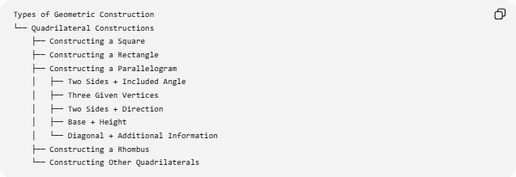
Types of Geometric Construction
└── Quadrilateral Constructions
├── Constructing a Square
├── Constructing a Rectangle
├── Constructing a Parallelogram
│ ├── Two Sides + Included Angle
│ ├── Three Given Vertices
│ ├── Two Sides + Direction
│ ├── Base + Height
│ └── Diagonal + Additional Information
├── Constructing a Rhombus
└── Constructing Other Quadrilaterals
A more detailed construction structure is:
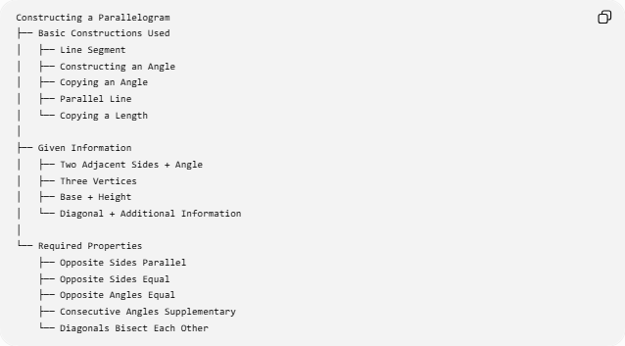
Constructing a Parallelogram
├── Basic Constructions Used
│ ├── Line Segment
│ ├── Constructing an Angle
│ ├── Copying an Angle
│ ├── Parallel Line
│ └── Copying a Length
│
├── Given Information
│ ├── Two Adjacent Sides + Angle
│ ├── Three Vertices
│ ├── Base + Height
│ └── Diagonal + Additional Information
│
└── Required Properties
├── Opposite Sides Parallel
├── Opposite Sides Equal
├── Opposite Angles Equal
├── Consecutive Angles Supplementary
└── Diagonals Bisect Each Other

Parallelogram and Other Quadrilateral Constructions
# Source: AI Source: Provided by: [Data Path: Persons Table -> ID Column: 1, Name_En Column: Motasem Essam] -> From: [ChatGPT] on [7/25/2026]
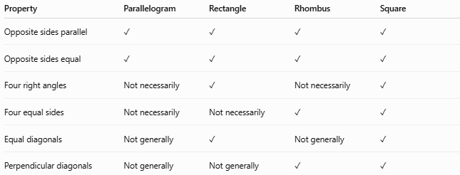
Property | Parallelogram | Rectangle | Rhombus | Square
Opposite sides parallel | ✓ | ✓ | ✓ | ✓
Opposite sides equal | ✓ | ✓ | ✓ | ✓
Four right angles | Not necessarily | ✓ | Not necessarily | ✓
Four equal sides | Not necessarily | Not necessarily | ✓ | ✓
Equal diagonals | Not generally | ✓ | Not generally | ✓
Perpendicular diagonals | Not generally | Not generally | ✓ | ✓
A square is a special case of both a rectangle and a rhombus, while a rectangle and rhombus are special cases of a parallelogram:
$$\boxed{\text{Square}⊂\text{Rectangle}⊂\text{Parallelogram}}$$
and:
$$\boxed{\text{Square}⊂\text{Rhombus}⊂\text{Parallelogram}}$$

Example
# Source: AI Source: Provided by: [Data Path: Persons Table -> ID Column: 1, Name_En Column: Motasem Essam] -> From: [ChatGPT] on [7/25/2026]
Construct a parallelogram with:
$$AB=7\text{ cm} \\ AD=4\text{ cm}$$
and:
$$∠DAB={60}^{∘}$$
Construction
- Construct $AB=7$cm.
- At $A$, construct a ${60}^{∘}$angle.
- On the second ray, construct $AD=4$cm.
- Through $B$, construct a line parallel to $AD$.
- Through $D$, construct a line parallel to $AB$.
- Their intersection is $C$.
Therefore:
$$AB=CD=7\text{ cm} \\ AD=BC=4\text{ cm}$$
The perimeter is:
$$P=2\left(7+4\right) \\ \boxed{P=22\text{ cm}}$$
Since the included angle is ${60}^{∘}$, the height relative to $AB$is:
$$h=4\sin{{60}^{∘}}=2\sqrt{3}$$
Therefore:
$$A=7\left(2\sqrt{3}\right) \\ \boxed{A=14\sqrt{3}{\text{ cm}}^{2}}$$

Tools Used
# Source: AI Source: Provided by: [Data Path: Persons Table -> ID Column: 1, Name_En Column: Motasem Essam] -> From: [ChatGPT] on [7/25/2026]
Straightedge
Used to:
- draw sides
- draw parallel lines
- connect vertices
- extend construction lines
Compass
Used to:
- transfer side lengths
- copy angles
- construct perpendiculars and other auxiliary constructions
Therefore:
$$\boxed{\text{Classical Parallelogram Construction}=\text{Straightedge + Compass}}$$

Key Points
# Source: AI Source: Provided by: [Data Path: Persons Table -> ID Column: 1, Name_En Column: Motasem Essam] -> From: [ChatGPT] on [7/25/2026]
- A parallelogram has two pairs of opposite sides parallel.
- Opposite sides are equal.
- Opposite angles are equal.
- Consecutive angles are supplementary.
- Its diagonals bisect each other.
- Two side lengths alone do not uniquely determine a parallelogram.
- An included angle or equivalent directional information is needed.
- A parallelogram can be constructed from three vertices by constructing two parallel lines.
- Its area is:
$$A=bh$$
- Its perimeter is:
$$P=2\left(a+b\right)$$
- A rectangle, rhombus, and square are all special types of parallelograms.

Conclusion
# Source: AI Source: Provided by: [Data Path: Persons Table -> ID Column: 1, Name_En Column: Motasem Essam] -> From: [ChatGPT] on [7/25/2026]
Constructing a Parallelogram is the geometric construction of a quadrilateral whose two pairs of opposite sides are parallel. The fundamental method constructs two adjacent sides and then uses parallel-line constructions to locate the remaining vertex. The construction relies especially on line-segment construction, angle construction, copying lengths, and constructing parallel lines. A parallelogram becomes a rectangle when its angles are right angles, a rhombus when all four sides are equal, and a square when both conditions occur.

